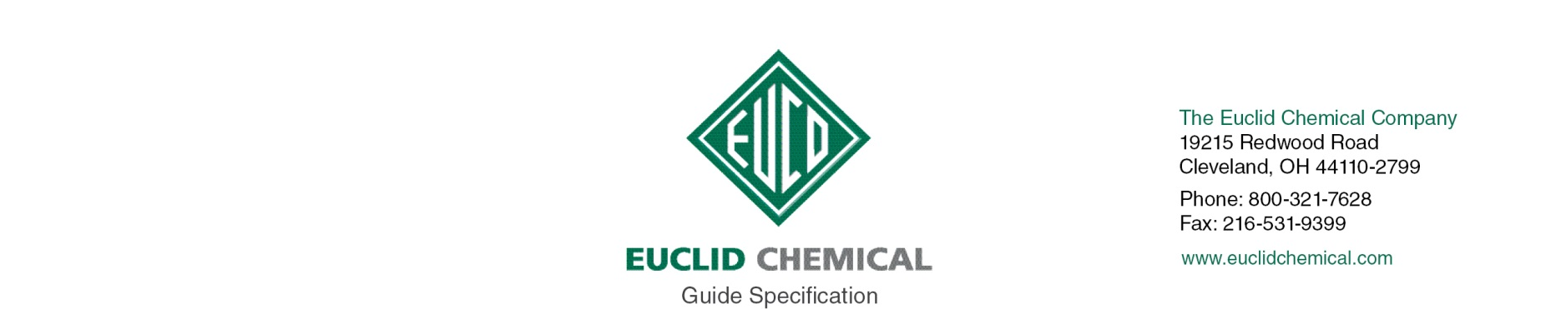
ULTRASIL LI+
{Note to Specifier: This add-in specification component specifies Euclid Chemical Company, ULTRASIL Li+ Densifier Sealer for Concrete Floors}

ULTRASIL Li+ is a water-based lithium silicate solution used to densify, seal and dust proof concrete surfaces. UltraSil Li+ penetrates and chemically reacts within the concrete surface, producing extremely hard and dense calcium silicate hydrate (CSH) in the pores. The result is concrete that is more durable, easier to clean, and more resistant to damage from water and mild chemicals. Because the product of the lithium silicate-concrete reaction is formed internally, the protection of UltraSil Li+ never peels or flakes off, is unaffected by moisture, and lasts much longer than surface sealers and coatings.

{Note to Specifier: The paragraphs below are meant to be incorporated into Parts 2 and 3 of a standard CSI 3 Part Format specification, project’s General Structural Notes or directly onto the plans. They must be carefully reviewed by a qualified design professional and edited to meet the particular requirements of the project at hand, assure compliance with any governing building codes, and coordinate with other specification sections and drawings.}

1.1 QUALITY REQUIREMENTS

A. Manufacturer: ISO 9001 quality certified as primary manufacturer of specified products.

1.2 INFORMATIONAL SUBMITTALS

A. Product List: List manufacturer name and product name for each product proposed for use as concrete admixture and surface treatment.

B. Manufacturer Certificate: Indicating products listed on Contractor's Product List are compatible and suitable for the specified application.

PART 2- PRODUCTS

2.1 MANUFACTURERS

A. Manufacturer: Provide listed products of Euclid Chemical Co., Cleveland, OH; www.euclidchemical.com.

B. Manufacturer Single Source: Provide densifier sealer and related concrete treatment and admixture products from a single qualified manufacturer.

2.2 LIQUID FLOOR TREATMENTS

A. Lithium Silicate Densifier: Water based, deep penetrating, minimum 15% active ingredient solution containing lithium silicate designed to harden, densify, and dustproof concrete surfaces.
1. Basis of Design Product:
a) UltraSil Li+ by The Euclid Chemical Co.

PART 3- EXECUTION

3.1 EXAMINATION

{Note to Specifier: Retain this Article when applying liquid micro-film sealer to existing concrete surfaces.}

A. When used on existing concrete, examine concrete surfaces to receive micro-film sealer. Notify specifier if surfaces do not comply with manufacturer's recommendations. Do not begin surface preparation or application until unacceptable conditions are corrected

3.2 PREPARATION

A. When used on existing concrete, prepare concrete surfaces in accordance with manufacturer’s written instructions.
1. Ensure surfaces are clean, dry and free of standing water.
2. Remove dirt, dust, oil, grease, sealers, and other materials that may prevent penetration liquid densifier sealer.

3.3 APPLICATION

A. Apply this Lithium Silicate Densifier in strict accordance with the directions of the manufacturer. Apply enough material to keep floor uniformly wet for minimum 15 minutes. Scrub or agitate wet material with soft bristle broom or micro fiber pad while material remains wet. Do not brush or agitate once material begins to dry.

